This document explains the implementation of the UNIFAC model. This will draw the analogies between the implementation proposed in (Smith, 1950) and (Muhieddine et al., 2022). The liquid activity coefficient is evaluated as follows:
$$\ln{γ_{i,t}}\left(x,T\right)=\ln{γ_{i,t}^{C}}\left(x,T\right)+\ln{γ_{i,t}^{R}}\left(x,T\right)$$
(Smith, 1950) | (Muhieddine et al., 2022)
Combinatorial part
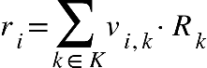
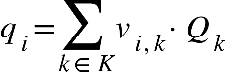
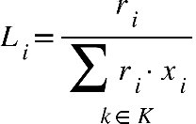
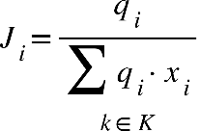
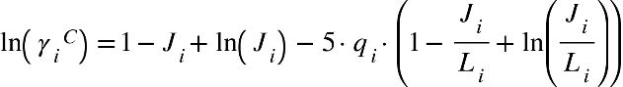
Residual part
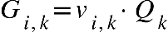 | 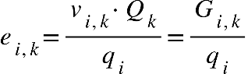
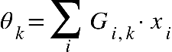 | 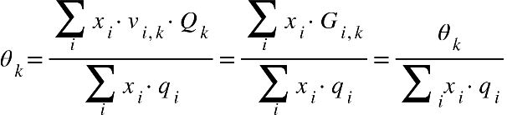
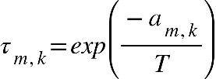 | 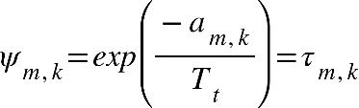
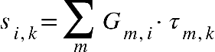 | 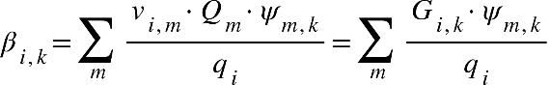
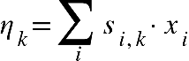 | 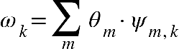
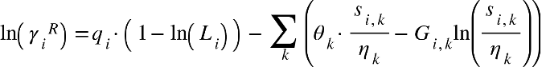 | 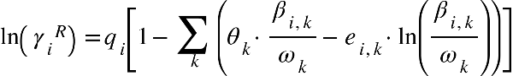

Literature
Muhieddine, M.H., Viswanath, S.K., Armstrong, A., Galindo, A., Adjiman, C.S., 2022. Model-based solvent selection for the synthesis and crystallisation of pharmaceutical compounds. Chemical Engineering Science 264, 118125. https://doi.org/10.1016/j.ces.2022.118125
Smith, J.M., 1950. Introduction to chemical engineering thermodynamics.

